NATIONAL EUCHARISTIC REVIVAL
YEAR OF PARISH REVIVIAL (2023–2024)
PARISH WIDE SMALL GROUPS USING THE “JESUS AND THE EUCHARIST” STUDY

TEMPLATE TABLE FACILITATOR INVITATION

PARISH POINT PERSON INSTRUCTIONS:

Please edit text highlighted in gray, as well as any other text you wish to alter.

Then (i) remove the gray highlighting, (ii) delete these instructions and all of the text above it, and (iii) attach this invitation document to an email from you to your invitee.

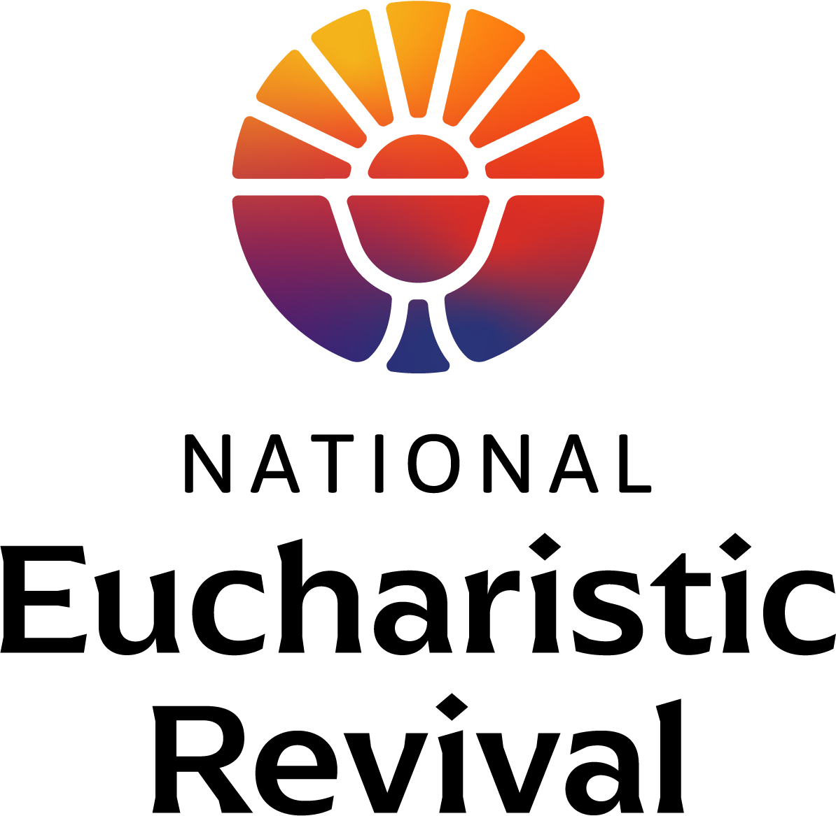

Dear [Invitee Name]:

The National Eucharistic Revival, a three-year initiative called for by the Bishops of the United States, is preparing for Year Two—the Year of Parish Revival (June 2023–June 2024). The Eucharistic Revival is a historic and transformative national movement to help the faithful fall in love with Jesus, especially in the Eucharist, and be inspired and equipped to share that love with others. (For a helpful infographic providing an overview of the three-year process and other information, go to http://www.eucharisticrevival.org.)

I am the Parish Point Person for the Eucharistic Revival work at our parish, and am assisted in this work by a Core Team of parishioners and staff. This fall we will host parish wide small groups using the foundational Eucharistic Revival study titled “Jesus and the Eucharist”. This is a 7 session study that has been created by the Eucharistic Revival team specifically for the Year of Parish Revival. The study begins with the initial kerygmatic proclamation of the Gospel and builds to God’s saving work in the Eucharist. The study will begin on [insert the date and time] and be completed before Thanksgiving.

I am writing to ask you to prayerfully consider being a table facilitator for this parish wide study. Listed below are the table facilitator expectations. You do not need to be an expert or theologian. You already have what it takes—a love of the Lord, especially in the Eucharist, and a desire to build up the body of Christ in His Church.

In addition, the Eucharistic Revival team intentionally designed the study to make the role of table facilitator easy to do. You will attend a live training, or view a video of training, in late August or September. Your role is limited to the table discussions; there is no home-work or pre-work. The host on the video will give instructions for the table discussions and provide a warning to wrap-up. Small group discussions will use a “Process for Invitation” where each person is invited to share before beginning an open table discussion.

God is doing a revival in our country and the Holy Spirit is working in so many ways. He is calling many people back to himself in the Eucharist. Please let me know by [insert date] if you will join me in this important work—I hope you say “yes”!

In Christ,
[Parish Point Person Name]

TABLE FACILITATOR EXPECTATIONS

- Attend/View a training: Attend a live training, or view a video of the training, for Table Facilitators offered in late August and September (approx. 30 minutes). The training will give an overview of the “Jesus and the Eucharist” study, including the participant materials. It will explain the “Process for Invitation” that will be used for table discussions and give ideas to keep the open table discussion positive.

- Faithful: Faithful practicing Catholic who desires to help others grow in their faith through the parish wide Eucharistic Revival small group study.

- Attend: Attend all 7 sessions of the study (or most of them), arriving a little early to welcome those parishioners who sit down at your table for the session.

- Encourage: Encourage and joyfully support the table members as you guide the discussions. Let members know you hear and see them, and value their input. Be a good listener.

