NATIONAL EUCHARISTIC REVIVAL
YEAR OF PARISH REVIVIAL (2023–2024)
PARISH WIDE SMALL GROUPS USING THE “JESUS AND THE EUCHARIST” STUDY

TEMPLATE EXISTING SMALL GROUP INVITATION

PARISH POINT PERSON INSTRUCTIONS:

Please edit text highlighted in gray, as well as any other text you wish to alter.

Then (i) remove the gray highlighting, (ii) delete these instructions and all of the text above it, and (iii) attach this invitation document to an email from you to your invitee.

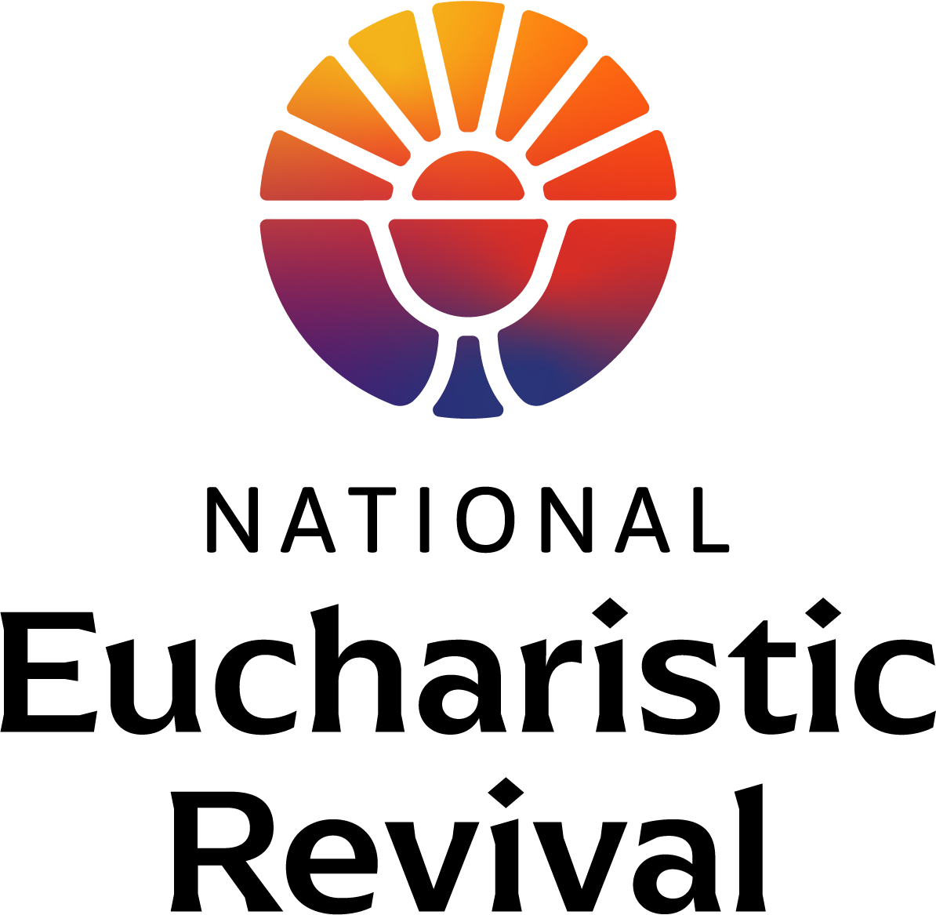

Dear [Small Group Facilitator Name]:

The National Eucharistic Revival, a three-year initiative called for by the Bishops of the United States, is preparing for Year Two—the Year of Parish Revival (June 2023–June 2024). The Eucharistic Revival is a historic and transformative national movement to help the faithful fall in love with Jesus, especially in the Eucharist, and be inspired and equipped to share that love with others. (For a helpful infographic providing an overview of the three-year process and other information, go to www.eucharisticrevival.org.)

I am the Parish Point Person for the Eucharistic Revival work at our parish. This fall we will host parish wide small groups using the foundational Eucharistic Revival study titled “Jesus and the Eucharist”. This is a 7 session study that has been created by the Eucharist Revival team specifically for the Year of Parish Revival. The study begins with the initial kerygmatic proclamation of the Gospel and builds to God’s saving work in the Eucharist. The parish wide study will begin on [insert the date and time] and be completed before Thanksgiving.

As a facilitator of a small group associated with our parish, I am writing to invite you and your small group to join our parish wide small group study (your small group is welcome to sit together at one of the tables) or, alternatively, to use the “Jesus and the Eucharist” study in your small group meetings.

If you wish to use the “Jesus and the Eucharist” study in your small group meetings, below are some additional details for your consideration:

- Each of the 7 sessions are 2 hours or less, with about half the time as table discussion.
- The study includes a video and participant handout for each session free of charge, although you will have to print the participant handouts.
- The video and participant handout will be posted to www.eucharisticrevival/parishpointperson weekly, starting Thursday, September 14. Your small group can start the study at your convenience.
- Your small group will need to provide a screen for your members to view the video.
- You will download the video in advance, and simply press play when you are ready to start. The video will run the entire 2 hours guiding you through a welcome by an Archbishop or Bishop, a time of lectio prayer, teachings and testimonies, and table discussions. A professional host guides the process.
- There is no pre-work or home-work. Additional optional resources will be provided.

If your small group would like to use this study, feel free to access the video and participant handouts at the www.eucharisticrevival.org/parishpointperson webpage. If you have any questions, or if I can help in any way, please let me know. After you are done, let me know about your small group experience.

God is doing a revival in our country and the Holy Spirit is working in so many ways. He is calling many people back to himself in the Eucharist. Please keep the Eucharistic Revival in your prayers.

May our Eucharistic Lord be praised and lifted high!

In Christ,
[Parish Point Person Name]

