NATIONAL EUCHARISTIC REVIVAL
YEAR OF PARISH REVIVAL (2023–2024)
PARISH-WIDE SMALL GROUPS USING THE “JESUS AND THE EUCHARIST” STUDY

TEMPLATE CORE TEAM MEMBER INVITATION

PARISH POINT PERSON INSTRUCTIONS:

Please edit text highlighted in gray, as well as any other text you wish to alter.

Then (i) remove the gray highlighting, (ii) delete these instructions and all of the text above it, and (iii) attach this invitation document to an email from you to your invitee.

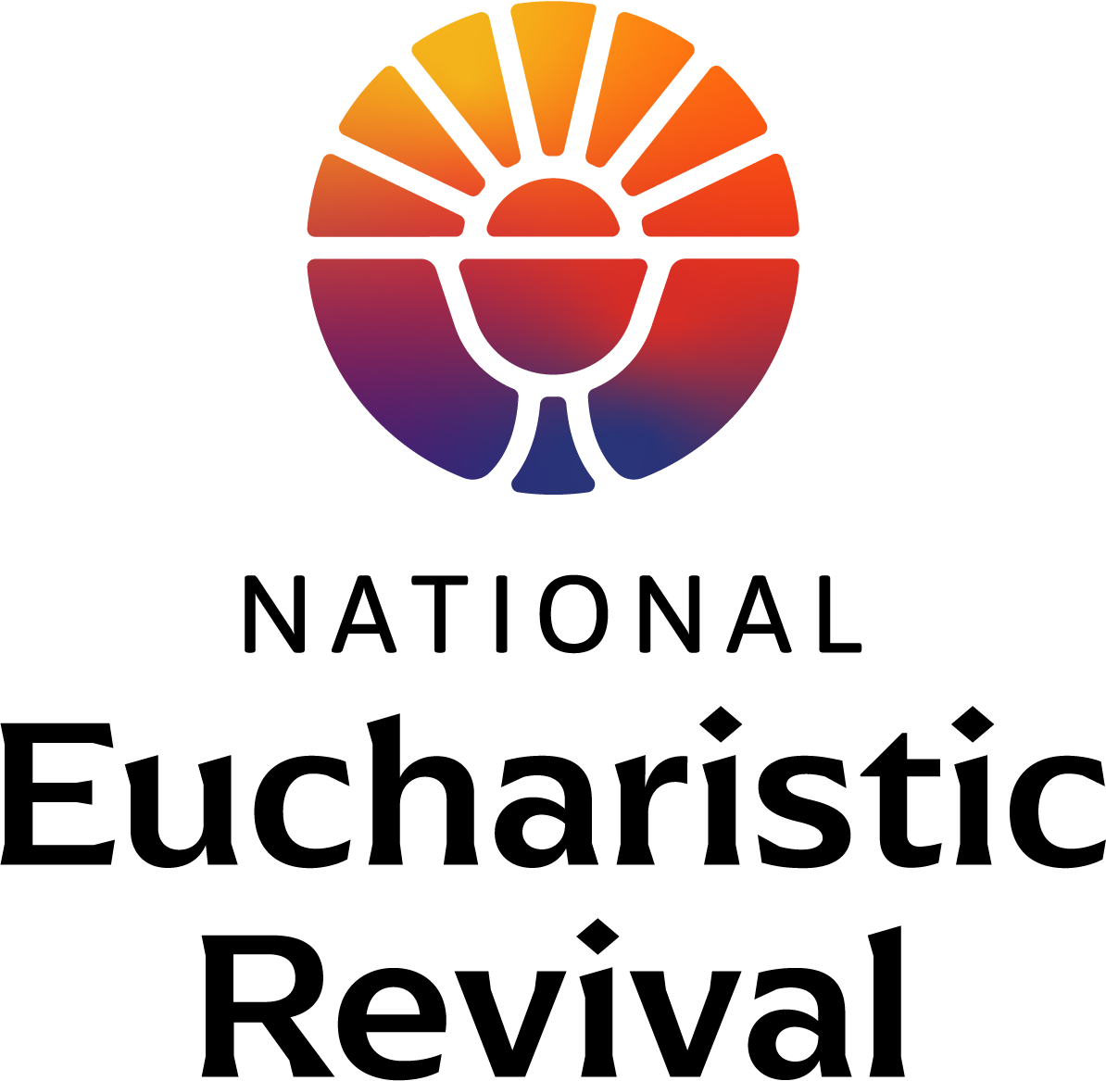

Dear [Invitee Name]:

The National Eucharistic Revival, a three-year initiative called for by the Bishops of the United States, is preparing for Year Two—the Year of Parish Revival (June 2023–June 2024). The Eucharistic Revival is a historic and transformative national movement to help the faithful fall in love with Jesus, especially in the Eucharist, and be inspired and equipped to share that love with others. (For a helpful infographic providing an overview of the three-year process and other information, go to www.eucharisticrevival.org.)

I am the Parish Point Person for the Eucharistic Revival work at our parish. This fall, we will host parish-wide small groups using the foundational Eucharistic Revival study titled “Jesus and the Eucharist.”

I am forming a Core Team to plan and implement this parish-wide small group study, and am writing to ask you to prayerfully consider joining me in this work as a Core Team member. Listed below is a brief job description and scope of work for your consideration. Our first Core Team meeting is
[insert date, time and location]. (Note: If you want more detailed information about this effort, feel free to view the Parish Point Person and Core Team member training for planning the small groups. The video of training will be posted to www.eucharisticrevival.org/parishpointperson in early April.)

You already have what it takes—a love of the Lord, especially in the Eucharist, and a desire to build up the Body of Christ in his Church. You do not need to be an expert or a theologian.

God is doing a Revival in our country, and the Holy Spirit is working in so many ways. He is calling many people back to himself in the Eucharist. Please let me know by [insert date] if you will join me in this important work—I hope you say "yes"!

In Christ,
[Parish Point Person Name]

CORE TEAM MEMBER JOB DESCRIPTION AND SCOPE OF WORK

- Job description of a Core Team member

  - Faithfulness/Desire: Faithful, practicing Catholic who prays and desires to help others fall in love with Jesus, especially in the Eucharist, and be inspired and equipped to share that love with others
  - Available Time: Has the time available to attend Core Team meetings and fulfill the scope of work
  - Experience: Preferably has participated in and/or facilitated a small group

- Scope of work for a Core Team member

  - Planning work in spring and early summer
    - Training #1 for Core Team members to Plan the Small Groups: At your earliest convenience, attend a live training or view a video of training provided by the Eucharistic Revival team for planning the parish-wide small group study (appx. 45 minutes). Register at www.eucharisticrevival.org/parishpointperson for a live training. A video of the training will be posted to the webpage in early April.
    - Core Team Meetings: Attend Core Team meetings to plan the small group study, estimated to be twice a month this spring.
    - Tasks: Complete assigned ministry tasks arising from these meetings. Tasks will involve planning and advertising our fall small groups, recruiting table facilitators, and preparing for hospitality and (if applicable) child care.

  - Implementation work in August through the end of the 7-session study
    - Training #2 for Core Team members to Implement Small Groups: In late August/September, attend a live training or view a video of training for implementing the small group study (appx. 45 minutes).
    - Training for Table Facilitators: In late August/September, attend a live training or view a video of training for Table Facilitators to understand their role so you can support them and answer questions that may arise (appx. 30 minutes).
    - Core Team Meetings: Attend a few Core Team meetings this fall as needed for implementation.
    - Tasks: Complete the tasks noted above, along with preparing the rooms for the small groups to meet (tables, video screen, and participant handouts).
    - Attend: Participate in the 7 sessions of the study (or as many as possible) assisting in your role, which may be helping with room set-up, hospitality, or child care, and/or being a table facilitator or small group member.

