REGISTRATION DEADLINE: JAN. 20, 2023
JANUARY 28, 2023
Annual Women’s Conference
St. Thomas More/Seven Dolors
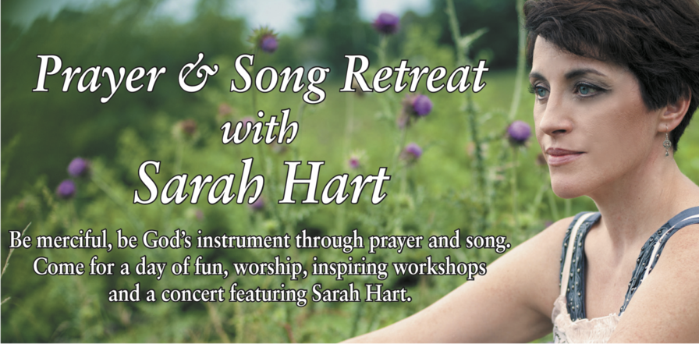

Sarah Hart is one of the leading figures in contemporary Catholic music today. Her songs of faith have touched the lives of millions. Originally from Lancaster, OH, she has a degree in music from Ohio State University. Now based in Nashville, she’s on the road a good part of the year juggling songwriting, recording, concerts, and a full events schedule. Sarah’s songs are part of the common worship experience of Catholics in the US: “Go in Peace,” “You Alone,” “Sweet Redeemer” and others. Her signature blend of folk, pop, and rock delights listeners of every age. She often co-writes with artists like Curtis Stephan, Steve Angrisano, and Jesse Manibusan. Her songs have been covered by Amy Grant, Celtic Women, Matt Maher, Jason Crabb and The Newsboys. Grant’s recording of Sarah’s “Better than a Hallelujah” earned a Best Gospel Song Grammy nomination. Sarah’s dynamic energy, sense of humor and deep faith make her retreats unforgettable experiences. She especially enjoys exploring topics around women’s ministry and spirituality. In October of 2013, Sarah was invited to perform for Pope Francis and a crowd of 150,000 in St. Peter’s Square. Sarah lives in Nashville with her husband and two daughters.

Please print legibly
Name _____________________________________________________

Address ________________________________________

_______________________________________________

Email _______________________________________________________
Phone ________________________________________

I need childcare : Yes____ Ages__________ No___
Early Registration Fee $45 (adults),
After Dec. 31, $50 $30 (students HS/College)
Late fee after Jan. 20 is $55
Make checks payable to St. Thomas More Memo:
Women’s Conference.
Mail registration forms and payment to:
Women’s Conference
2900 Kimball Ave.
Manhattan, KS 66502
http://bit.ly/WomConf23 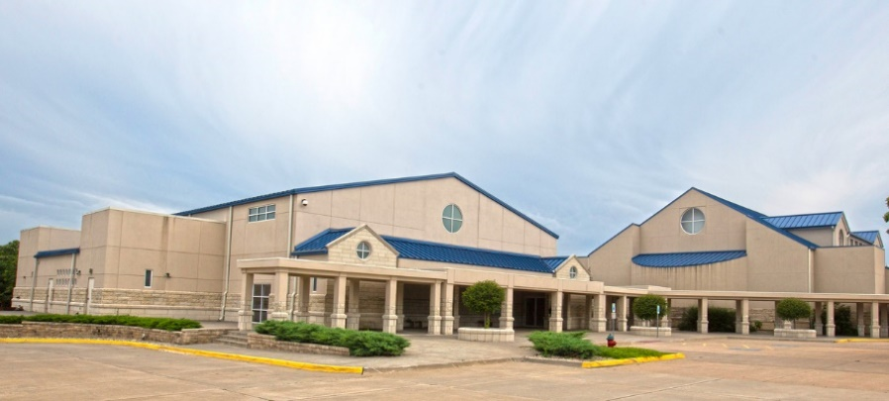
(Parish Center behind the church)

17th Annual
Women’s Spirituality Conference
January 28, 2023

[Grab your reader’s attention with a great quote from the document or use this space to emphasize a key point. To place this text box anywhere on the page, just drag it.]
Women’s Spirituality Conference is jointly
sponsored by the
Seven Dolors and St. Thomas More Women’s Groups.

This event is held annually at
St. Thomas More Parish Center
located at 2900 Kimball Ave., Manhattan
785-776-5151

Continental Breakfast /Gather 8:30a.m. – 9:00a.m.
Introduction and Presentation 9:00a.m. to Noon
Lunch Break Noon to 1:00p.m.
Presentation resumes 1:00p.m. to 3:30p.m.

Early Registration Fee (before Dec. 31) $45 (adults),
After Dec. 31, registration fee is $50 by Jan. 20
Late fee after Jan. 20 is $55.
$30 (students HS/College)
(all fees are non-refundable)

Make checks payable to St. Thomas More
Memo: Women’s Conference.
Or Register Online at our site: https://bit.ly/WomConf23

Questions? Email: Rosie Rundell at formation@sevendolors.com or
Alysia Bauman at reledsec@stmmanhattan.com.
Childcare provided.

