









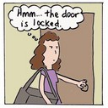


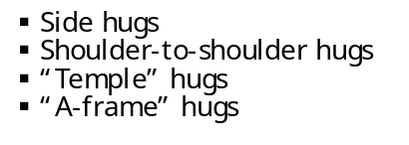
BOUNDARIES
Certain interactions with minors are more appropriate than others. When ministering with minors, are you maintaining appropriate healthy boundaries?
Appropriate
Inappropriate


- Side hugs
- Shoulder-to-shoulder hugs
- “Temple” hugs
- “A-frame” hugs
- Handshakes
- Holding hands during prayer
- Holding hands (when escorting younger children)
- Verbal praise
- Positive affirmation
- Encouragement
- High fives
- Fist bumps
- Kissing
- Lengthy embraces
- Any form of affection that is not wanted by the minor
- Comments about a minor’s physique or physical development
- Being alone with a minor in isolated areas
- Cursing
- Name calling
- Secrets
- Massages
- Tickling
- Wrestling
- Piggy-back rides
- Calling or sending emails or text messages to individual students
- Online gaming
- Asking my students to be my “friend” online
- Pats on shoulder or head where/when culturally appropriate
- Posting things online that are…
-true
-helpful
-inspiring
-necessary
-kind

T
H
I
N
K

BOUNDARIES
Certain behaviors with minors are more appropriate than others. When ministering with minors, are you maintaining healthy behavioral boundaries?
Appropriate
Inappropriate

Appropriate behavior between adults and minors constitutes a positive part of church life, ministry and healthy child development. Depending on the circumstance, the following forms of behavior are customarily regarded as appropriate ways to maintain healthy boundaries.
Inappropriate behavior between adults and minors is not a positive part of church life, ministry and healthy child development. The following are regarded as inappropriate behavior and should not be used in ministry, as they do not exhibit high ethical standards and personal integrity.
- Participating in online gaming with a minor

- Being alone with a minor(s), without another responsible adult present, in any closed area that is inappropriate while working in the scope of a ministry program, such as a vehicle, restaurant, sleeping facility, locker room, restroom, hot tub or pool

- Allowing minors to have or assisting minors in gaining access to alcohol, drugs, pornographic material or any illegal substance

- Allowing minors to have or assisting minors in gaining access to inappropriate media such as websites, movies, videos, music, DVDs, CDs, etc.

- Photographing minors while at school or in CCD programs without the proper parental/guardian consent
- Consistently abiding by the Code of Conduct

- Providing a safe environment where the dignity of every individual is ensured

- Knowing how and where to report alleged/suspected abuse

- Maintaining a professional relationship when interacting with minors; avoiding emotional attachment and/or vulnerable situations

- Maintaining an awareness of the powerful attraction of minors to adults in positions of authority and trust. If a personal or physical dependency begins to develop, the minor is to be referred to another qualified adult.

